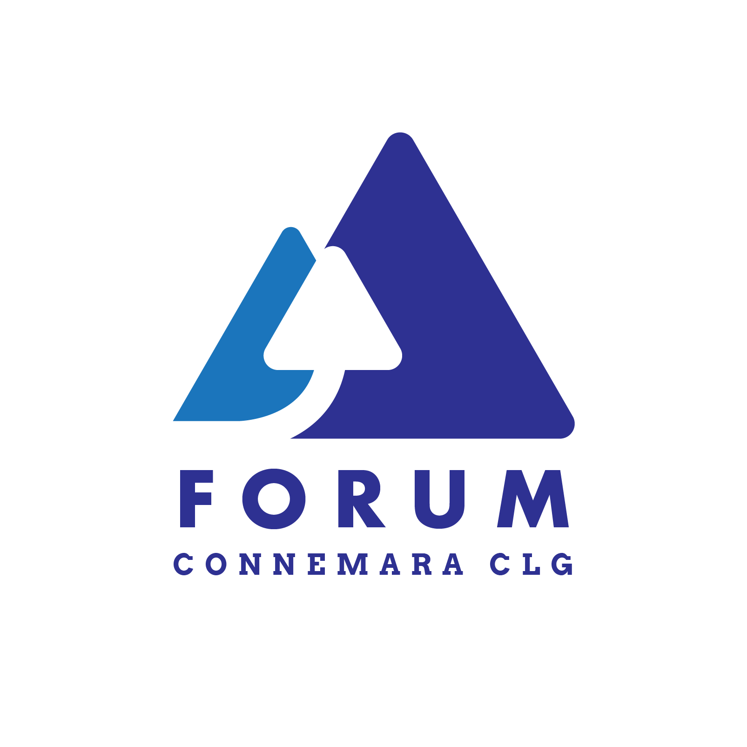

Application Number (for office use only)

Membership Application Form - Community & Voluntary Group 2020

Name of Group: ________________________________________________________________________
Group Contact Details
Name of Contact 1: ______________________________________________________________
Email address of contact 1: ______________________________________Phone: __________________
Name of Contact 2: ______________________________________________________________
Email address of contact 2: ______________________________________Phone: __________________
Address of group: ___________________________________________________
___________________________________________________
Membership Criteria
Community & Voluntary Sector Membership is open to active groups operating within North & West Connemara. Such groups must:
- Be in existence more than 6 months Be not-for-profit
- Be active Support the FORUM Connemara ethos
Send completed application form to: info@forumconnemara.ie or post to Forum Connemara CLG, Ellis Hall, Letterfrack, Connemara, Co. Galway.
Data Protection: All details supplied on this Application Form will only be used by FORUM Connemara CLG to keep its members up to date on its activities or to inform you of other relevant information. This data will not be passed to any third party and will be keep in line with GDPR regulations 2018.
Each organisation shall be entitled to nominate one person to attend and participate at general meetings of the company.

I confirm that ______________________ (group) meets the criteria for membership and wishes to be a member of FORUM Connemara CLG.

Signed: ___________________________________________ Date: _______________________________
If you have any queries please contact FORUM on 095-41116 - thank you.

